Tuesday, 22 June 2021
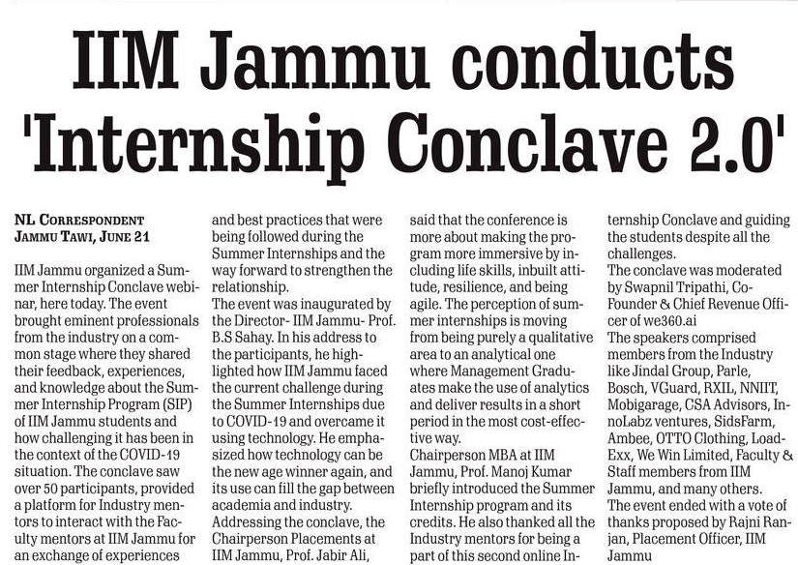

Tuesday, 22 June 2021

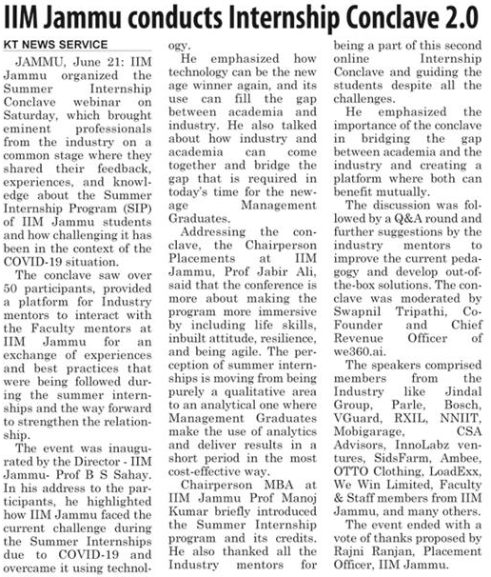

IIM Jammu conducts Internship Conclave 2.0
Jammu, June 21 (Scoop News)-IIM Jammu organized the Summer Internship Conclave webinar on 19th June 2021. The event brought eminent professionals from the industry on a common stage where they shared their feedback, experiences, and knowledge about the Summer Internship Program (SIP) of IIM Jammu students and how challenging it has been in the context of the COVID-19 situation. The conclave saw over 50 participants, provided a platform for Industry mentors to interact with the Faculty mentors at IIM Jammu for an exchange of experiences and best practices that were being followed during the Summer Internships and the way forward to strengthen the relationship.

The event was inaugurated by the Director- IIM Jammu- Prof. B.S Sahay. In his address to the participants, he highlighted how IIM Jammu faced the current challenge during the Summer Internships due to COVID-19 and overcame it using technology. He emphasized how technology can be the new age winner again, and its use can fill the gap between academia and industry. He also talked about how industry and academia can come together and bridge the gap that is required in today’s time for the new-age Management Graduates. He further discussed the limitations of the current pedagogy that could be balanced through the firm, speedier, and reliable feedback from the industry- regardless of abilities. He even invited all the Industry mentors to visit the Campus once the COVID-19 restrictions are relaxed. Needless to say, the pandemic has transformed the centuries-old, chalk-talk teaching model into one driven by technology.
Addressing the conclave, the Chairperson Placements at IIM Jammu, Prof. Jabir Ali, said that the conference is more about making the program more immersive by including life skills, inbuilt attitude, resilience, and being agile. The perception of summer internships is moving from being purely a qualitative area to an analytical one where Management Graduates make the use of analytics and deliver results in a short period in the most cost-effective way.
Chairperson MBA at IIM Jammu Prof. Manoj Kumar briefly introduced the Summer Internship program and its credits. He also thanked all the Industry mentors for being a part of this second online Internship Conclave and guiding the students despite all the challenges. He emphasized the importance of the conclave in bridging the gap between academia and the industry and creating a platform where both can benefit mutually.
The discussion was followed by a Q&A round and further suggestions by the industry mentors to improve the current pedagogy and develop out-of-the-box solutions. The conclave was moderated by Mr. Swapnil Tripathi, Co-Founder & Chief Revenue Officer of we360.ai
The speakers comprised members from the Industry like Jindal Group, Parle, Bosch, VGuard, RXIL, NNIIT, Mobigarage, CSA Advisors, InnoLabz ventures, SidsFarm, Ambee, OTTO Clothing, LoadExx, We Win Limited, Faculty & Staff members from IIM Jammu, and many others.
The event ended with a vote of thanks proposed by Mr. Rajni Ranjan, Placement Officer, IIM Jammu.

